Software Requirements Specifications

GB Dry Fruits

Project Code:
SEP383946

Project Advisor:
Ms. Samreen Razaq

Project Manager:
Dr. Muhammad Ilyas

Project Team:
Muhammad Sajid Bsef18m039 (Team leader)
Muhammad Saqlain Bsef18m038 (Team member)
Rafiuddin Bsef19m046 (Team member)

Submission Date:
Oct. 8, 2021

___________________

Project Manager’s Signature
Document Information

Category | Information
Customer | University Of Sargodha
Project | GB Dry Fruits
Document | Requirement Specifications
Document Version | 1.0
Identifier | SEP383946
Status | First
Author(s) | Muhammad Sajid Bsef18m039 (Team leader)  Muhammad Saqlain Bsef18m038 (Team member)  Rafiuddin Bsef19m046 (Team member)
Approver(s) | Dr. Muhammad Ilyas
Issue Date | Oct. 19, 2022
Document Location
Distribution | - Supervisor  - PM  - Project Office

Definition of Terms, Acronyms, and Abbreviations

Term | Description
RS | Requirements Specifications
SRS | Software Requirement Specification
JS | Java Scripts
HTML | Hypertext Markup language
CSS | Cascading Style Sheets
GB | Gilgit Baltistan
UI | User Interface
UX | User Experience

Table of Contents

1. Introduction 4
2. Overall System Description 4
2.3 System Constraints 5
3. External Interface Requirements 5
3.1 Hardware Interfaces 6
3.2 Software Interfaces 6
3.3 Communications Interfaces 7
4. Functional Requirements 7
5. Non-functional Requirements 8
5.6 User Documentations 9
6. Assumptions and Dependencies 9
7. Use Cases 10
7.1 Use Case Diagrams 10
7.1.1 User Login 11
7.1.2 Home screen 11
7.1.3 Products 11
7.1.4 Order 12

7.1.5 Feedback 12
7.1.6 Admin login 12
7.1.7 Manage System 13
7.2 Use Case Description 13
8. Graphical User Interfaces 15
9. High Level Design 16
9.1 ER Diagram 16
9.2 Data Dictionary 16
9.2.1 User 16
9.2.2 Admin 17
9.2.3 Product 17
9.2.4 Order 17
Table 9.2.4 Data Design Table for Order 17
9.2.5 Shipment 18
9.2.6 cart 18
9.2.7 Delivery 18
9.2.8 Feedback 18
10. Requirements Traceability Matrix 19
11. Risk Analysis 19
12. Cost Estimation Sheet 21
13. References` 22

Introduction

Purpose of Document
This SRS document explains what our system is capable of and how it will perform. SRS reduces the time and effort required by project developers to achieve desired results, as well as the development cost. The intended audience are, project manager, project developers, customer, project advisor, and end users. This document is important in assisting the intended audience in understanding the system and will act as a guide for the development team.

Project Overview
The natural, delicious, and healthful fruits found in our land are a blessing. The dry fruits of GB stand out for both their flavor and their significance. Dry fruits serve a variety of purposes for many individuals, including their nutritional value, the treatment of certain infections, and more. For this reason, GB Dry Fruits is a web-based platform that will supply all the information about dry fruits, including which dry fruit is healthy and which is expensive, to companies and marketplaces. The residents of places like Gilgit Baltistan are having a tough time profiting from their dry fruit assets because of poor sales and a lack of purchasers. Our primary objective is to educate the people of Gilgit Baltistan on the importance of properly storing and exhibiting dried fruits.

Scope
Sale and purchase are two of the features you may expect to see on our website. The features that our system will provide are add to cart, update cart, billing detail, shopping cart with express checkout, secured payment, WhatsApp chat integrations, international language support, preservation technique, map with direction, integrated social media, enquiry form, home delivery, online payment, cash on delivery, discount offers. We regret that we cannot make our website available across the whole of Pakistan at this time due to a lack of resources and personnel. Current access to our website is limited to visitors from the region of Gilgit Baltistan only.

Overall System Description
GB dry Fruits will be a website where the project's software requirements are determined by fundamental aspects such as client-server architecture, database characteristics, and UI/UX design. The general elements that will impact the product and its requirements must be discussed in this section of the SRS.

User Characteristics
The system will allow both regular users and administrators to access it. The system's user must be familiar with the fundamentals of operating system and using the internet. The user must be proficient in reading and comprehending English. It is assumed that the user is familiar enough with a computer to operate the browser, keyboard, and mouse.

Operating Environment
- The website operates on any client web browser like Microsoft Bing, Internet Explorer, Firefox, Netscape, and Google.
- PHP, Laravel framework, React framework
- SQLite, MySQL server database

  - System Constraints

Communication Constraints

The communication protocol must work. The system must have access to the location of the device. Through TCP/IP, the system must communicate.

User Constraints

For those who cannot buy dry fruits physically, this system will facilitate people to purchase the products easily. This system will be utilized by those looking for work as home delivery agents.

Hardware Constraints
Server Side:
- Processor (Minimum Pentium 2.24 GHz)
• RAM: 8GB or more
• Hard disk: 500 GB or max (for backup)
Client Sides:
• Processor: ARMV7 Processor
• RAM: 4 GB or more
• Hard disk: Minimum 4 GB (for backup)

External Interface Requirements
Multiple external requirements are necessary for the proper functioning of the web Application. These requirements are divided into many classes including hardware, software, communication, etc.

Context Diagram:

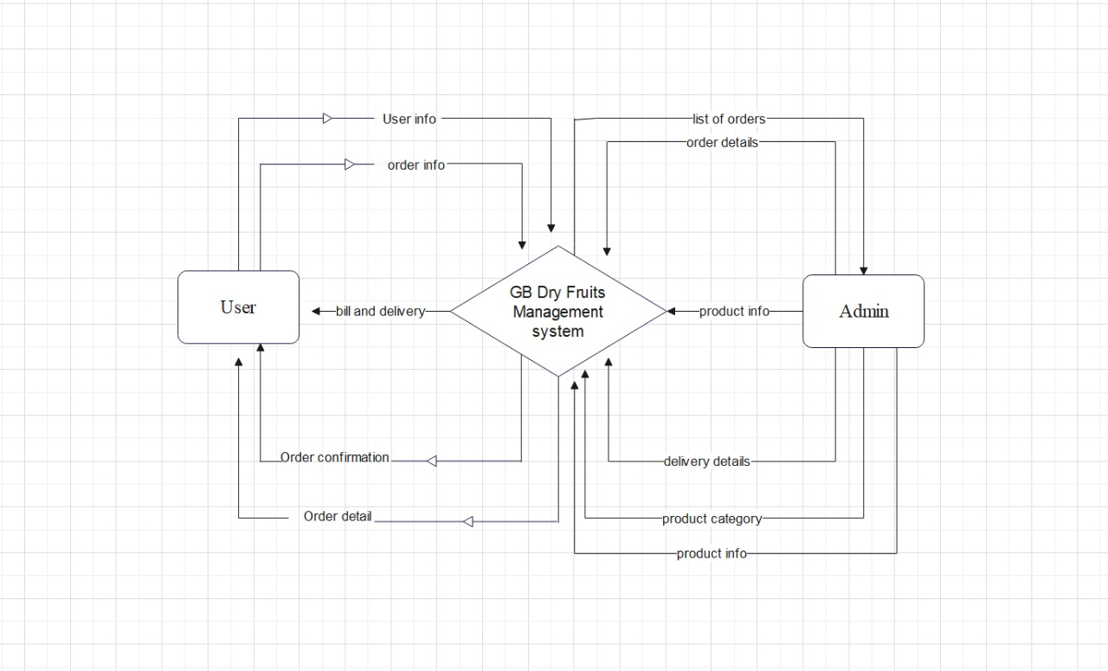

  - Hardware Interfaces
All server-side components must execute on server computers. All client-side components must execute on workstation and personal computers. Hardware interfaces are divided into two categories into client side and server side.
Client Side:
- Web Browser (Any web browser)
- Processor (Minimum Pentium 2.24 GHz)
- Ram (4 GB)
- Storage Space 4 GB (for backup)
Server Side:
- Local server
- Web application server (any)
- Processor (Minimum Pentium 2.24 GHz)
- Ram 8 GB or more

  - Software Interfaces
Operating System
We choose Windows OS as our operating system because it has a simple and user-friendly interface.
Database
The data has been stored using the MySQL and SQLite database technology.
Developing Technologies
GB dry fruits will be developed in HTML, CSS, Bootstrap, and JavaScript.
  - Communications Interfaces
The communication architecture must follow the client-server model. Communication between the client and server should utilize a REST-compliant web service and must be served over HTTP Secure (HTTPS). The client-server communication must be stateless. A uniform interface must separate the client roles from the server roles.

Functional Requirements
The requirements for the GB Dry Fruits are contained in this subsection. The features discussed in the vision document are used to organize these requirements. To best capture, the functional requirements of the system, features from vision documents are refined into use case diagrams and sequence diagrams.

Independent functionality modules
To provide all of the functionality necessary to solve the stated problem, various modules are combined into a single system. Every module's functioning is maintained separately from the others so that it will not affect the entire system.

Managed Database Design.
To prevent complexity during routine check-ups and maintenance, all of the data saved in the database is kept in a standardized format.

Provide Customer Support.
For issues in using the system by entities, customer support is offered.

Business profiles.
Not only is the system designed for business purposes but also provides awareness about unique dry fruits, and preservation techniques. In this regard, business profiles for business, entities are created on GBDF.

Provide detailed sitemap.
The wording information is not sufficient to identify every single consumer and retailer; thus, a comprehensive roadmap is added to GBDF for help.

Non-functional Requirements

Performance Requirements
The system speed, accuracy, capacity, safety, and dependability were all increased by the performance characteristics when used for searches and other purposes. The system’s huge capacity means that it will respond to every user at once even if the maximum number of users use it. Safety means that the system must deliver accurate data that is completely secure in the event of a security issue. Our website should, hopefully, carry out all of these functions precisely.

Safety Requirements
The database could crash at any time as a result of a virus or operating system failure. Therefore, it is necessary to create a database backup to prevent database loss. If the power source fails, a suitable UPS or inverter facility should be available[4].

Security Requirements
Similar to many other websites, security systems require database storage to meet their security requirements. However, due to the particular requirements of the security sector, vendors must be careful in choosing their database partners. Therefore, the issue with data loss and other numerous aspects, such as authorization, resulting from the security needs is solved by addressing the problem that is the root of the problem. The login system thus provides a secure solution for all of these needs[4].

Availability Requirements
In the availability requirements, describe the system's accessibility to customers through a web browser. Therefore, anyone at any moment can use our system's GB dry fruits. Users can use the system throughout Gilgit Baltistan. Availability requirements are a crucial component of the system.

Reliability Requirements
In the reliability requirements, describe the system's level of dependability for users under various circumstances. Which module is the most trustworthy for users based on performance needs? The modules put together the entire system, and the testing engineer then provides a report on the system's dependability. Therefore, system reliability requirements are a key component.

5.6 User Documentations
In user documentation, our team offers video tutorials to consumers so they may learn how our system work. Users of our system now have a clear understanding of how the functionality works and how the system as a whole performs. Our team offers the notebook, in which the complete system's operation is written. Users can read the notebook and quickly comprehend how the system works as a whole. Therefore, these are two simple approaches that any local user can utilize to comprehend the entire system

Assumptions and Dependencies
Assumptions:
Assumptions are a very important part of any system. So, some are the assumptions of our system GB Dry Fruits.
- There should be no mistakes in the coding[5].
- The system needs to be user-friendly so that users would find it simple to use.
- The system should be more capable and offer quick database access.
- The system should facilitate rapid transactions and offer search functionality[6].
- The GBDF system is active around-the-clock.
- Users can access from any computer with internet connectivity and online browsing capabilities.
- Users must have their correct usernames and passwords to access their online accounts and carry out operations.
Dependencies:
The assumption and dependencies that might affect our system are as follows:
- The hardware and software needed to operate the system[7].
- The project will be developed and carried out by the listed requirements and specifications.
- The product should be properly understood by the end users[8].
- The generic report store should be available on the system.
- All users' information must be stored in a database that the GB Dry Fruits system can access[9].

Use Cases

  - Use Case Diagrams

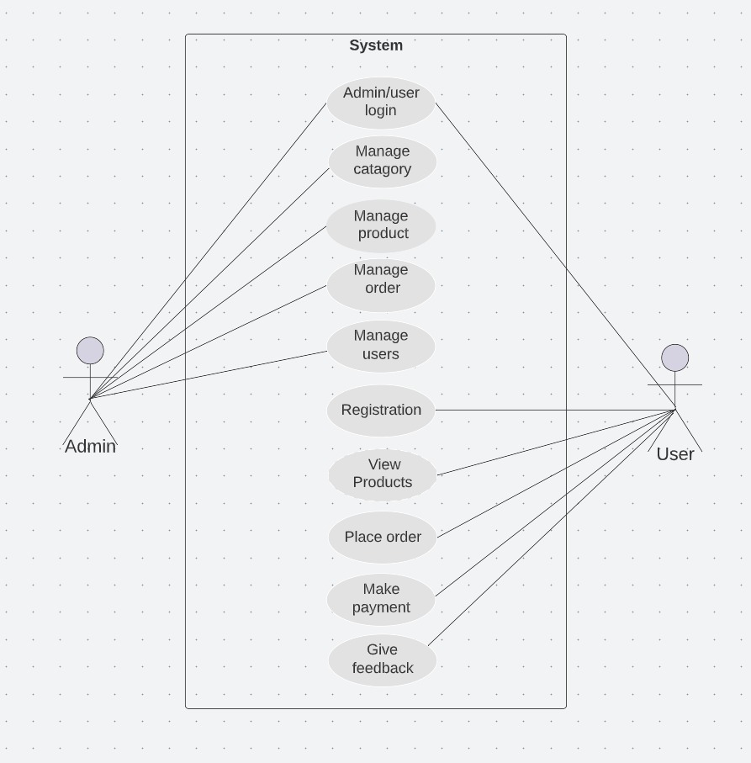

    - User Login
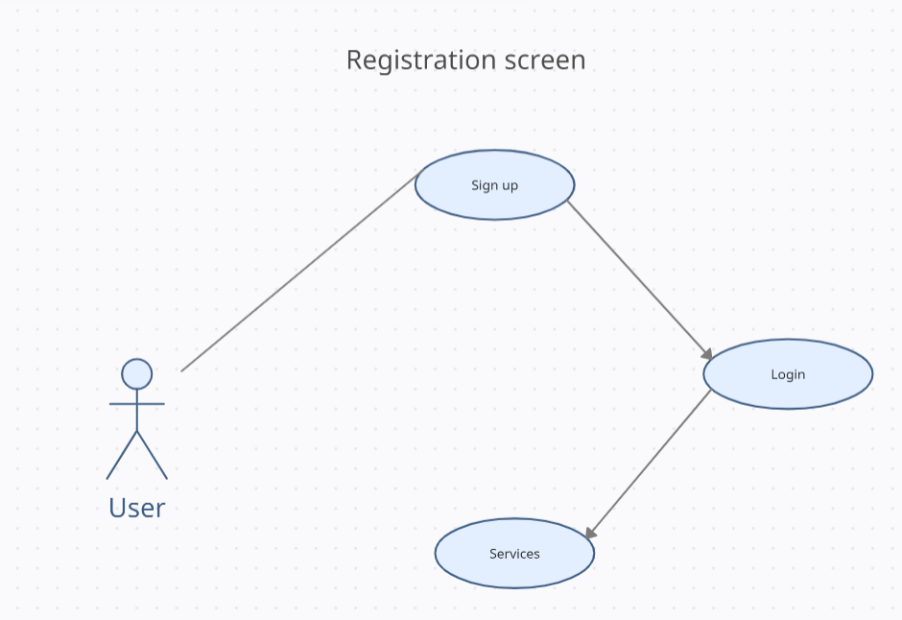
    - Home screen
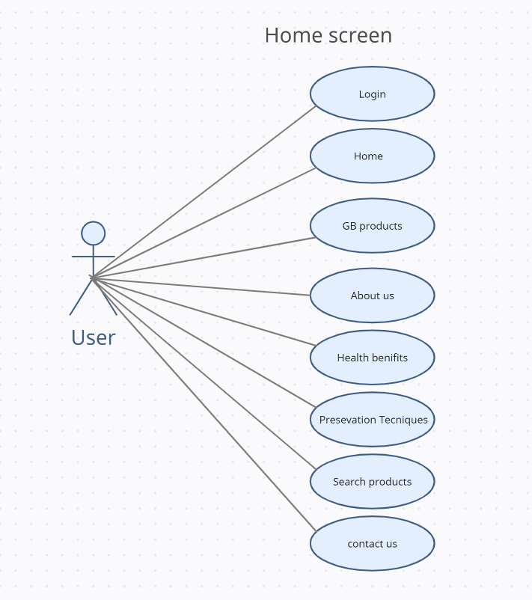
    - Products
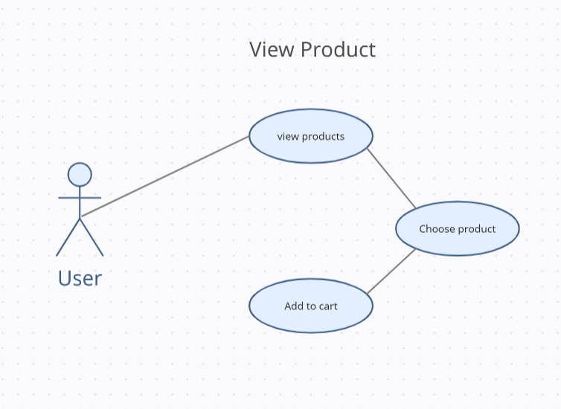
    - Order
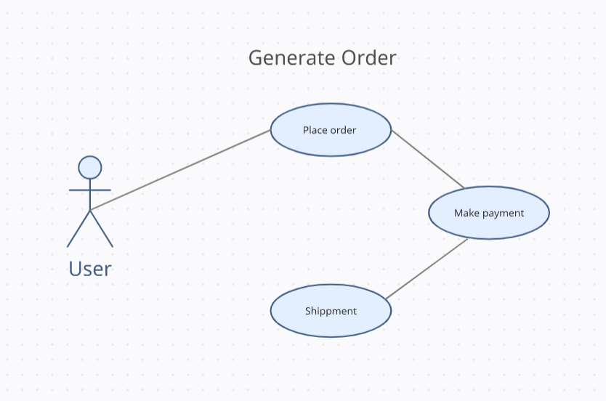
    - Feedback
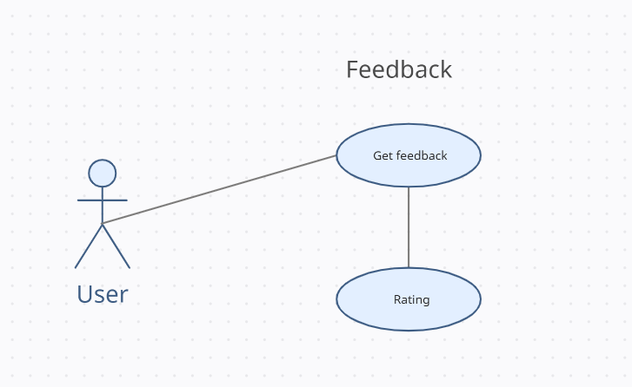
    - Admin login
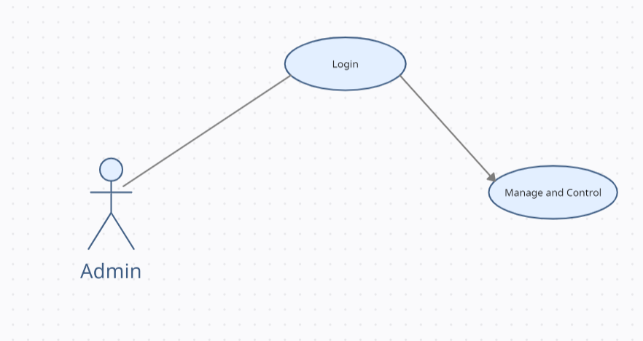

    - Manage System
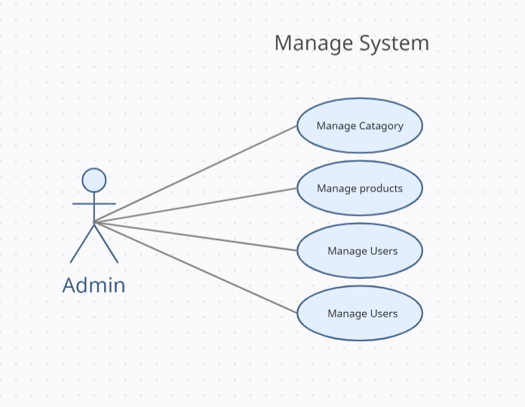

  - Use Case Description

UC-1: Use Case
Actors: Primary actor(user)
Secondary actor (service provider)
Feature: <Feature from which the use case is driven>
Use case Id: |  | UC-1
Pre-condition: |  | Before using the system, a user must register and create an account. Once logged in, then the user can start interacting with the system.
Scenarios
Step# | Action |  |  | Software Reaction
1. | The user will provide the credentials to create an account. |  |  | The system will create an account for the ser
2. | The user will log in to the system. |  |  | The database will authenticate the user details and then proceed with the entry of the user into the system accordingly.
3. | The user will place the order. |  |  | The system will manage the order and store the information of the order.
4. | The user will pay the payment. |  |  | The system will make the express checkout, manage payment and store the payment information.
Alternate Scenarios:
1a: Admin manages and updates products, prices, and scope of the system.

2a: Users view the system and give feedback

Post Conditions
Step# | Description
1. | Users can interact with the user interface of the GB Dry Fruits
2. | Admin can edit and update the products, price of the products, and manage the system.
User Interface reference |  |  | - Create account  - View pages  - Place order
Concurrency and Response
- Number of concurrent users is 220 - 250
- Expected response time is 1-10 sec

Graphical User Interfaces

UI-1: interfaces
Interface Id. | UI-1
Use case Reference | UC-1
Snapshot
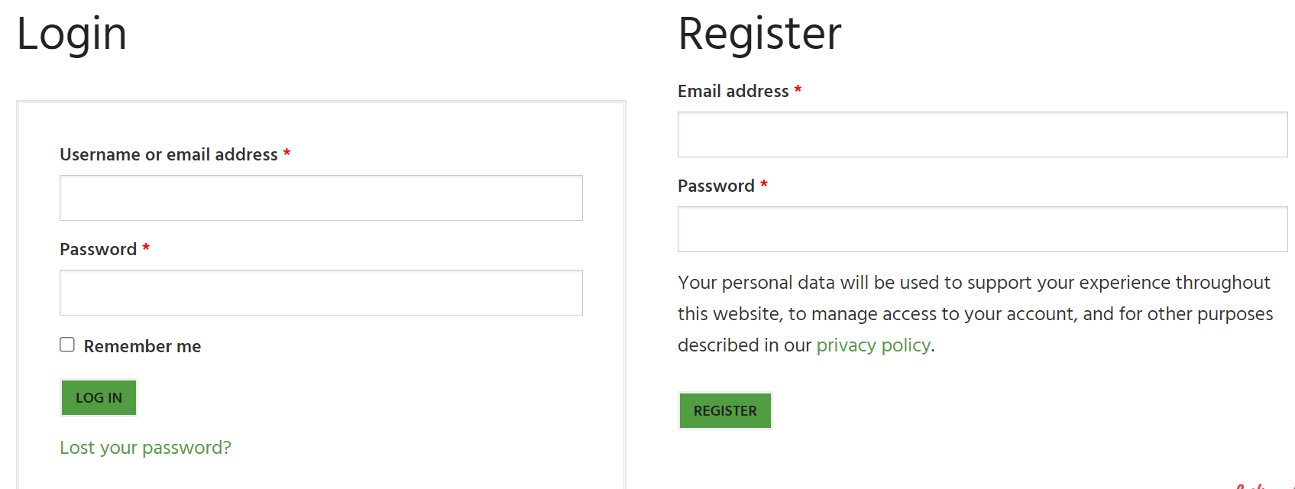

Home page interface About page interface
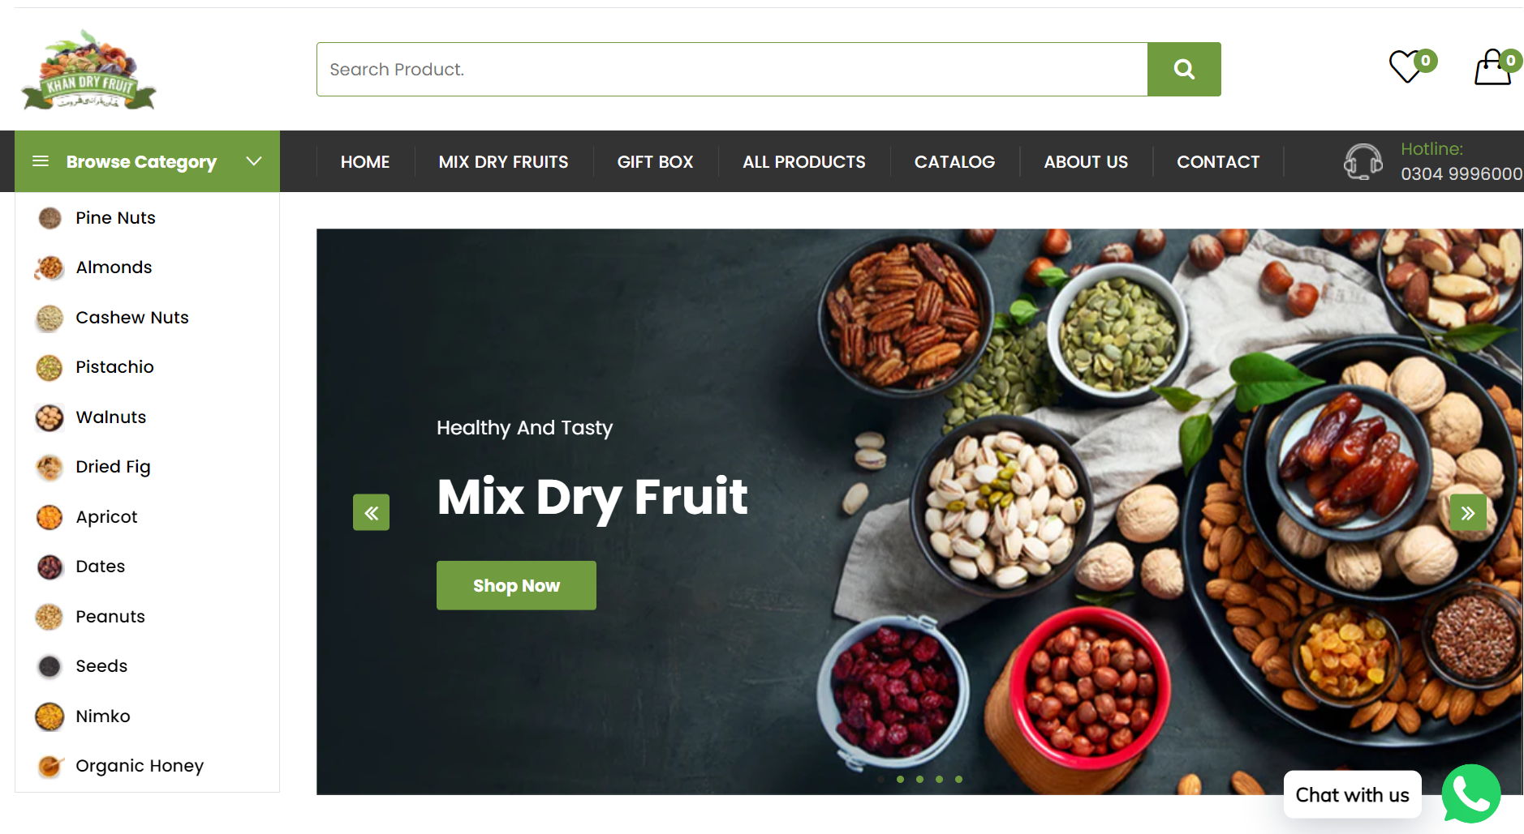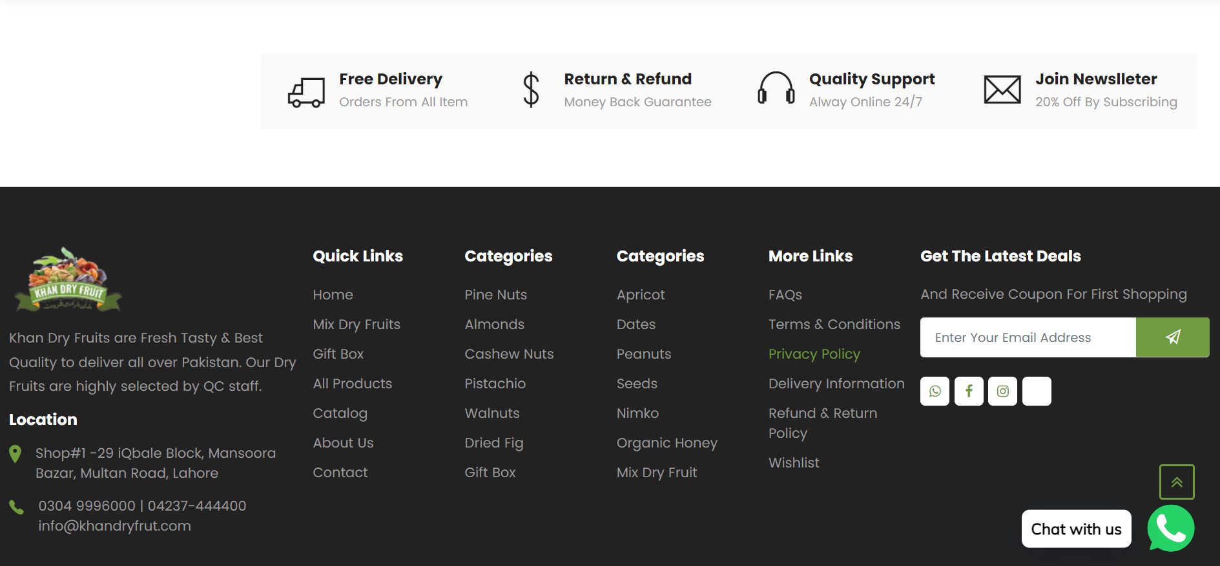

Products interface
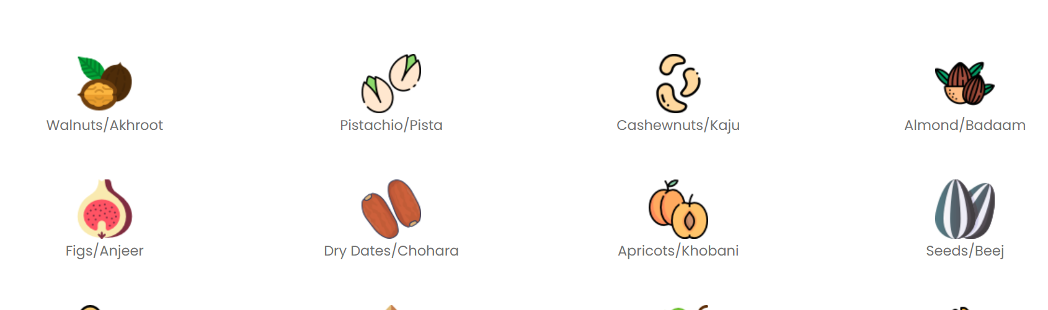

High Level Design
  - ER Diagram
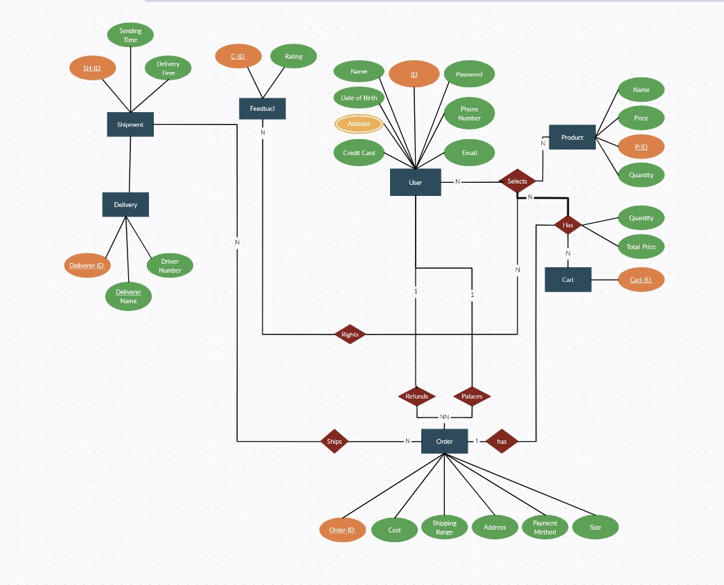

  - Data Dictionary
The convention recommended for writing the data dictionary is as follows.
    - User
Table 9.2.1 Data Design Table for user
Field Name | Type | Specification | Constraint | Unique | Description
ID | int | 11 Numeric characters | Not Null | Yes | User’s ID (primary key)
Name | String | 10 alphabetic characters | Not Null | Yes | User’s Name
Date of Birth | int | 10 Numeric characters | Not Null | Yes | User’s Date of Birth
Address | String | 30 Alphabetic characters | Not Null | yes | User’s Address
Credit Card | Debit Card | Alphabetic characters | Not Null | yes | Card number. Cardholder Name. Expiry Date.
E-mail | Varchar | 30 alphanumeric characters | Not Null, Primary Key | Yes | Gives the e-mail id of the user
Password | String | 10 alphanumeric characters | Not Null | Yes | login password; At least contain 8 characters including special characters
Phone Number | Integer | 11 integer characters | Not Null | Yes | User’s phone number required to provide strengthens trust due to local connection, increases revenue & customer satisfaction.

    - Admin
Table 9.2.2 Data Design Table for admin
Field Name | Type | Specification | Constraint | Unique | Description
Username | String | 10 alphabetic characters | Not Null | Yes | Admin’s username
Gender | String | 1 alphabetic character(M/F) | Not Null | No | Admin’s gender
E-mail | Varchar | 20 alphanumeric characters | Not Null, Primary Key | Yes | Gives the e-mail id of the user
Password | String | 10 alphanumeric characters | Not Null | Yes | login password At least contain 8 characters including special characters

    - Product
Table 9.2.3 Data Design Table for product
Field Name | Type | Specification | Constraint | Unique | Description
Name | String | 15 Alphabetic Character | Not null | Yes | Unique name for every product
Price | int | 6 Numeric Character | Not null | Yes | Sale Price of the product
P-ID | int | 20 Alphanumeric characters | Not null | yes | The admin will provide the Product ID to products to manage it Easily.
Quantity | integer | 50 integers characters | Not null | yes | The Quantity of the product that the user has to purchase.

    - Order
Table 9.2.4 Data Design Table for Order
Field Name | Type | Specification | Constraint | Unique | Description
Order-ID | int | 15 Numeric characters | Not Null | Yes | Order ID (primary key)
Cost | int | 6 Numeric characters | Not Null | Yes | Cost of the product
Shipping Range | int | 10 Numeric characters | Not Null | No | the time it takes for a package to travel from its sender to its destination.
Address | String | 50 Alphabetic characters | Not Null | yes | User’s Address
Payment Method | Debit Card | Alphabetic characters | Not Null | yes | Card number. Cardholder Name. Expiry Date.
Size | int | 50 alphanumeric characters | Not Null | Yes | Size of the product that the customer wants to purchase.

    - Shipment
Table 9.2.5 Data Design Table for Shipment
Field Name | Type | Specification | Constraint | Unique | Description

SH-ID | int | 15 Numeric Number | Not null | Yes | Package ID, Tracking number, or Delivery Confirmation Number

Shipment Time | int | 10 Numeric Number | Not Null | No | the length of time retailers set aside to go through all the processes between receiving an order and shipping it out.
Delivery Time | int | 10 Numeric Number | Not Null | No | The date of delivery is when the shipment arrives at the customer's home.

    - cart
Table 9.2.6 Data Design Table for Cart
Field Name | Type | Specification | Constraint | Unique | Description

Cart-ID | int | 9 Numeric characters | Not null | Yes | The shopping cart has a unique identifier (or "cart ID") consisting of nine digits.

Quantity | int | 30 Alphanumeric characters | Not Null | Yes | The number of items in a user's cart is shown.
Total Price | int | 6 Numeric Character | Not Null | Yes | Full price of a consumer item excluding tax and deposit.

    - Delivery
Table 9.2.7 Data Design Table for Delivery
Field Name | Type | Specification | Constraint | Unique | Description

Deliverer-ID | int | 20 alphanumeric characters | Not null | Yes | Id of every delivery boy.

Deliverer Name | String | 50 Alphanumeric characters | Not Null | Yes | Name of the delivery boy.
Deliverer Number | int | 11 Numeric Character | Not Null | Yes | Contact number of every delivery boy.

    - Feedback
Table 9.2.8 Data Design Table for Feedback
Field Name | Type | Specification | Constraint | Unique | Description

User-ID | int | 20 alphanumeric characters | Not null | No | user ID is used to identify a user on a website.

Rating | String | 5 Steric Character | Not Null | No | It is a product review based on a customer's thoughts and experiences.

Requirements Traceability Matrix

Sr. # | Feature | Use case ID | UI ID | Priority | Build Number | Use Case Cross reference  (Related Use Cases)
1 | User Login | UC-1 | UI-1 | 1 | 7.1.1 | Login
2 | Home Screen | UC-1 | UI-1 | 2 | 7.1.2 | Home Screen
3 | Product | UC-1 | UI-1 | 3 | 7.1.3 | Home Screen
4 | Order | UC-1 | UI-1 | 4 | 7.1.4 | Product
5 | Feedback | UC-1 | UI-1 | 7 | 7.1.5 | User
6 | Admin Login | UC-1 | UI-1 | 1 | 7.1.6 | Login
7 | Manage System | UC-1 | UI-1 | 2 | 7.1.7 | Login

Risk Analysis
Undisputedly there are risks in a website which are unavoidable. Wherever a user connects to the internet, there are intruders attempting to compromise the user's confidentiality, integrity of data, and the availability of services.
- Risk Identification
Online sales are frequently the primary business strategy, but there are dangers to consider in addition to the benefits. These hazards include illegal data sharing, fraud, malware, and other security breaches, as well as vulnerabilities associated with dealing with third-party platforms, data privacy laws, internet security legislation, and customer service concerns. Some of the E-Commerce risks are as follow:

- Data privacy and online security risks:
Hackers become smarter every day. Malicious actors may more easily get access to your systems from the inside by phishing for employee credentials or by sending malicious links in emails.
- Unauthorized access:
Not everyone requires project files. Unauthorized access causes data loss.
- Exploitation of vulnerabilities:
Malicious actors wait to exploit network weaknesses. Unpatched software, and older systems leave you vulnerable.
- Human error:
Human error causes most data loss, and it's usually an innocent mistake.
- Platform downtime:
Even the world's most recognized platforms require downtime to upgrade servers, security, and programming. However, long or regular downtime hurts productivity and reputation.
- Incompatible software:
If a solution is incompatible with our platform, we may be surprised when nothing works or appears right.
- Loss of premises due to disasters
Disasters happen, and they come in many guises. Fire, flooding, building collapse, electrical grid failure, power surges, internet failure

- Risk Drivers
- Exceed budget:
The cost of a project is crucial for both customers and developers. It estimates the overall budget. If project needs to change over time, it may impact the cost and cause firms to abandon the project.
- Running out of time:
Due to the following factors, starting a project might sometimes be delayed.
- incorrect planning
- incorrect resource allocation
- incorrect correction
- last-minute adjustments
- Inappropriate Requirements:
Uncertain requirements might cause project failure. Non-functional needs are as significant as functional ones. Missing one criterion may increase project time, cost, and risk.
- Lack of better management:
Poor project management is common. The right project manager prepares and devises solutions to reduce risks. He schedules each phase.
- Lack of resources:
The scenario that stretched your resources to the limit might have several reasons.
- New technology
- Unforeseen events
- Poor planning

- Percentage Impact of Risk Drivers
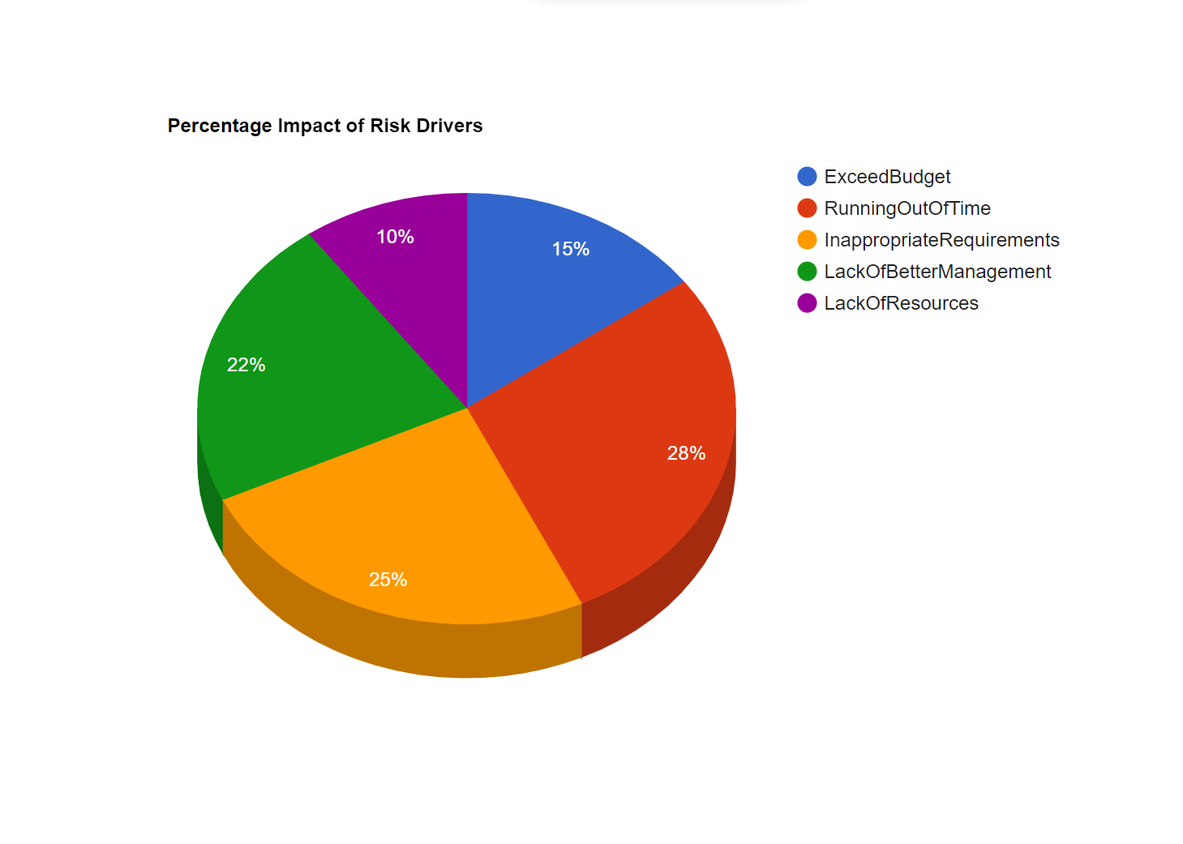
- Risk Mitigation Plan
If you don’t want your company to be part of the statistics, take the necessary steps to protect yourself. Implementing the solutions outlined above will reduce risk, lower liability, and help you recover quickly if you do experience an incident.
- Ensure your security protocols are updated.
- Institute strong security policies around passwords and work devices.
- Regularly monitor for suspicious or fraudulent activity.
- Use security platforms and firewalls.
- Design, implement and enforce a strong security policy.
- Educate your staff on how to detect incoming security threats.
- Implement regular security training sessions for all employees and contractors.
- Work on your disaster recovery planning (DRP) and update regularly.

Cost Estimation Sheet
 | Software development cost | Rs 57,500/-
 | Packaged software | Rs 44,999/-
 | Hardware | Rs 2,00000/-
 | Network | Rs 45,000/-
 | Client | Rs 5,543/-
 | Misc. | Rs 2,00000/-
 |  | Total cost =553,042/-

References`
[1] “Get Microsoft Bing,” Microsoft Store. https://www.microsoft.com/en-us/p/microsoft-bing/9nnhpwj0r912 (accessed Nov. 08, 2022).
[2] “Netscape ISP Homepage.” https://isp.netscape.com/ (accessed Nov. 08, 2022).
[3] “‘ibm,’ [Online]. Available: https://developer.ibm.com. - Google Search.” https://www.google.com/search?q=%22ibm%2C%22+%5BOnline%5D.+Available%3A+https%3A%2F%2Fdeveloper.ibm.com.&rlz=1C1GCEA_enPK1028PK1028&oq=%22ibm%2C%22+%5BOnline%5D.+Available%3A+https%3A%2F%2Fdeveloper.ibm.com.&aqs=chrome..69i57j33i160l4.1339j0j7&sourceid=chrome&ie=UTF-8 (accessed Nov. 08, 2022).
[4] S. Chatterjee, “Security and privacy issues in E-Commerce: A proposed guidelines to mitigate the risk,” in 2015 IEEE International Advance Computing Conference (IACC), 2015, pp. 393–396.
[5] C. Zott, R. Amit, and J. Donlevy, “Strategies for value creation in e-commerce: best practice in Europe,” European Management Journal, vol. 18, no. 5, pp. 463–475, 2000.
[6] R. R. Harmon, “Marketing Information Systems.,” Encyclopedia of information systems, vol. 3, pp. 137–151, 2002.
[7] S. Bagchi, G. Kar, and J. Hellerstein, “Dependency analysis in distributed systems using fault injection: Application to problem determination in an e-commerce environment,” 2001.
[8] E. L.-C. Law, V. Roto, M. Hassenzahl, A. P. Vermeeren, and J. Kort, “Understanding, scoping and defining user experience: a survey approach,” in Proceedings of the SIGCHI conference on human factors in computing systems, 2009, pp. 719–728.
[9] S. Gauch, M. Speretta, A. Chandramouli, and A. Micarelli, “User profiles for personalized information access,” The adaptive web, pp. 54–89, 2007.

